**SinkPAD™: Unmatched Thermal Performance for High-Power Headlights in ATVs, OHVs, Marine & Aerospace**

**High-Power Off-Road Illumination with SinkPAD™ 2x2 Modules**

The **SinkPAD™ 2x2 LED module** is a high-performance thermal PCB solution designed to drive **maximum luminous output** while maintaining low junction temperatures. Built with superior heat dissipation properties, this module ensures high reliability in **rugged off-road environments**.

Adura’s 2x2 LED modules can be seamlessly integrated into **off-road vehicle LED light bar** behind precision optics. These light bars are engineered to deliver **wide-area floodlighting** or **focused beam throw**—ideal for **ATVs, UTVs, trucks, and utility vehicles** tackling low-visibility terrain.

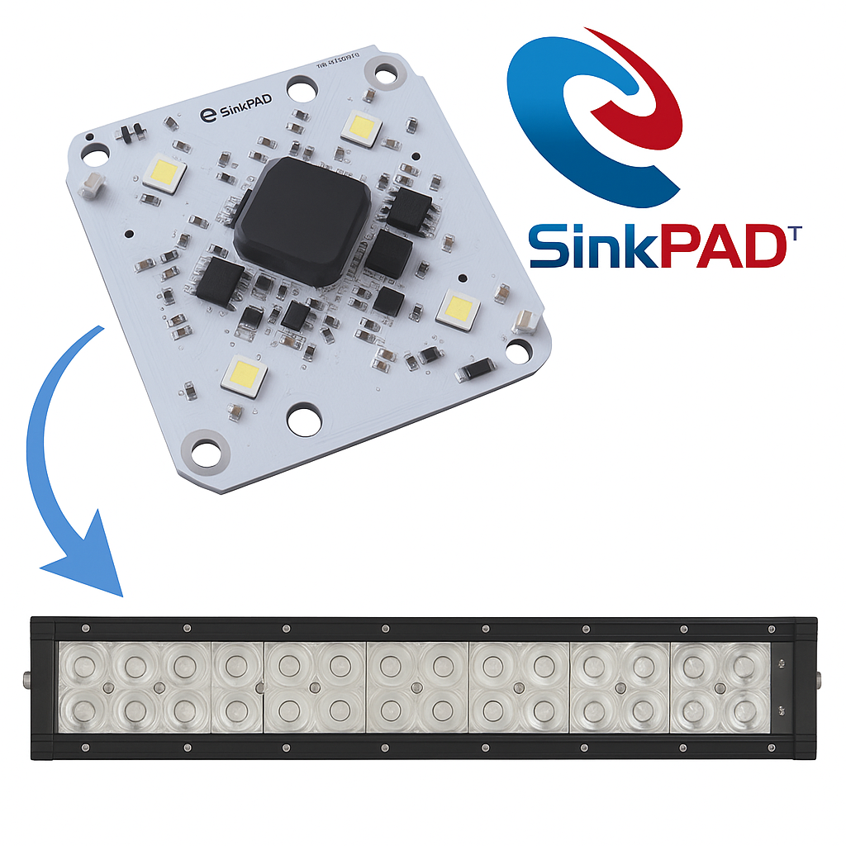

**🔧 Key Benefits:**

* **Thermal Excellence:** SinkPAD’s direct thermal path design ensures cooler operation, preventing lumen drop and LED failure.
* **Compact & Scalable:** The 2x2 layout enables modular integration for **custom beam configurations** in linear or curved light bars.
* **Enhanced Brightness:** Supports **higher drive currents** for increased lux and lumen output in compact housings.

**LED module Performance - Conventional Metal Core vs SinkPAD PCB**

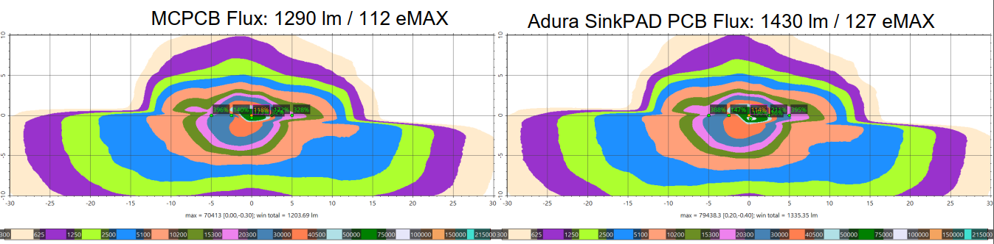

• **Higher Light Output:** Adura SinkPAD PCB delivers **1430 lm**, an **11% increase** over standard MCPCB’s 1290 lm, with improved overall luminous efficiency (127 vs. 112 eMAX).

• **Tighter Beam Focus:** The SinkPAD PCB produces a more concentrated beam with **higher central intensity** (up to 395%), enhancing long-range visibility.

• **Superior Thermal Management:** Better heat dissipation allows LEDs to run cooler and brighter, resulting in **more uniform optical performance** across harsh environments.

**Comparing Beam SinkPAD vs Convential Metal Core PCBs**

**MCPCB Performance**

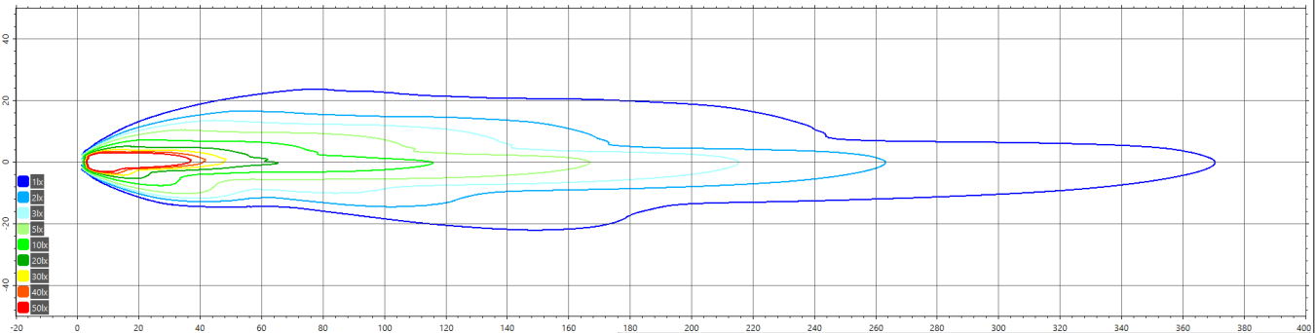

• **12% Brighter Output:** The SinkPAD PCB significantly boosts headlight performance, increasing beam intensity by **+12%** compared to standard Metal Core PCBs.

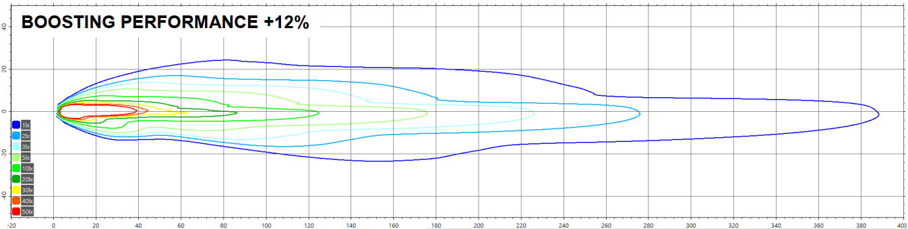• **Longer Throw Distance:** The SinkPAD design enables the beam to project farther with **tighter lux distribution**, improving visibility at extended distances—critical for high-speed and off-road applications

**SinkPAD PCB Performance**

• **12% Brighter Output:** The SinkPAD PCB significantly boosts headlight performance, increasing beam intensity by **+12%** compared to standard Metal Core PCBs.

• **Longer Throw Distance:** The SinkPAD design enables the beam to project farther with **tighter lux distribution**, improving visibility at extended distances—critical for high-speed and off-road applications.

• **Higher Center Intensity:** The denser, more concentrated hotspot in the SinkPAD beam (red/yellow zones) indicates **superior thermal and optical efficiency**, maximizing usable light where it matters most.

**Thermal Performance – SinkPAD vs Conventional Metal Core PCB**

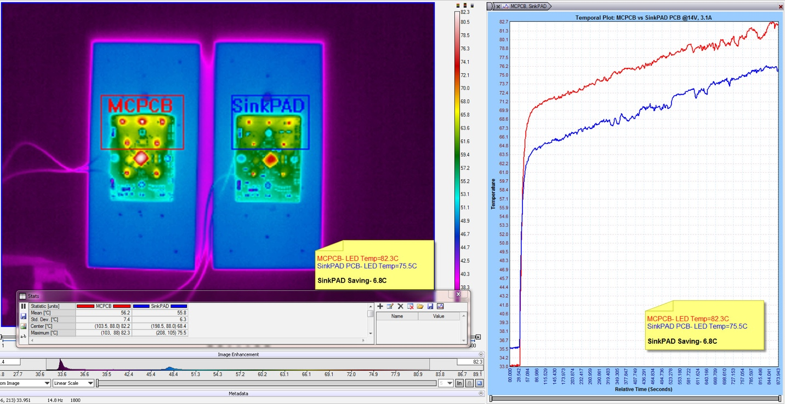

• **Runs 6.8°C Cooler:** SinkPAD reduces LED junction temperature from 82.3°C (MCPCB) to 75.5°C, significantly lowering thermal stress.

• **Improved Thermal Stability:** Consistently lower temperature curve over time ensures better performance under continuous operation.

• **Enhanced LED Lifespan & Efficiency:** Cooler operation boosts lumen output and extends the durability of high-power LEDs.

**Adura’s IATF16949 SinkPAD™ PCBs for Automotive Headlights**

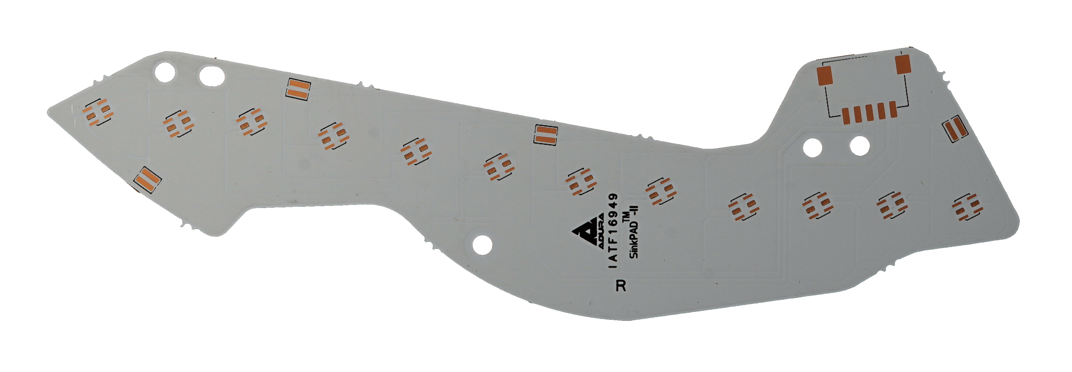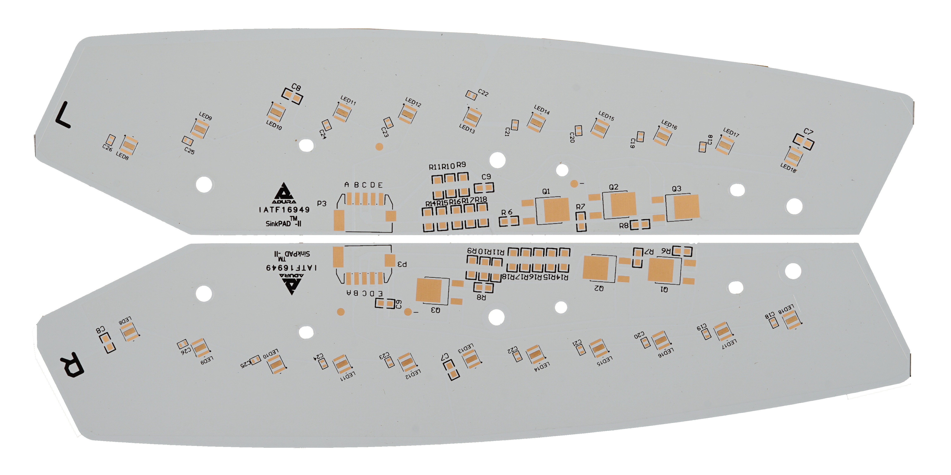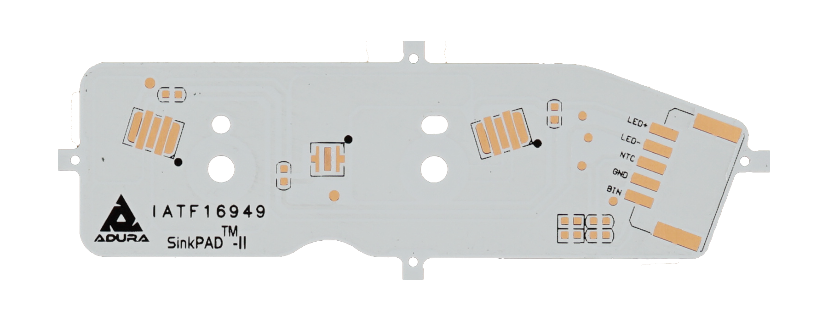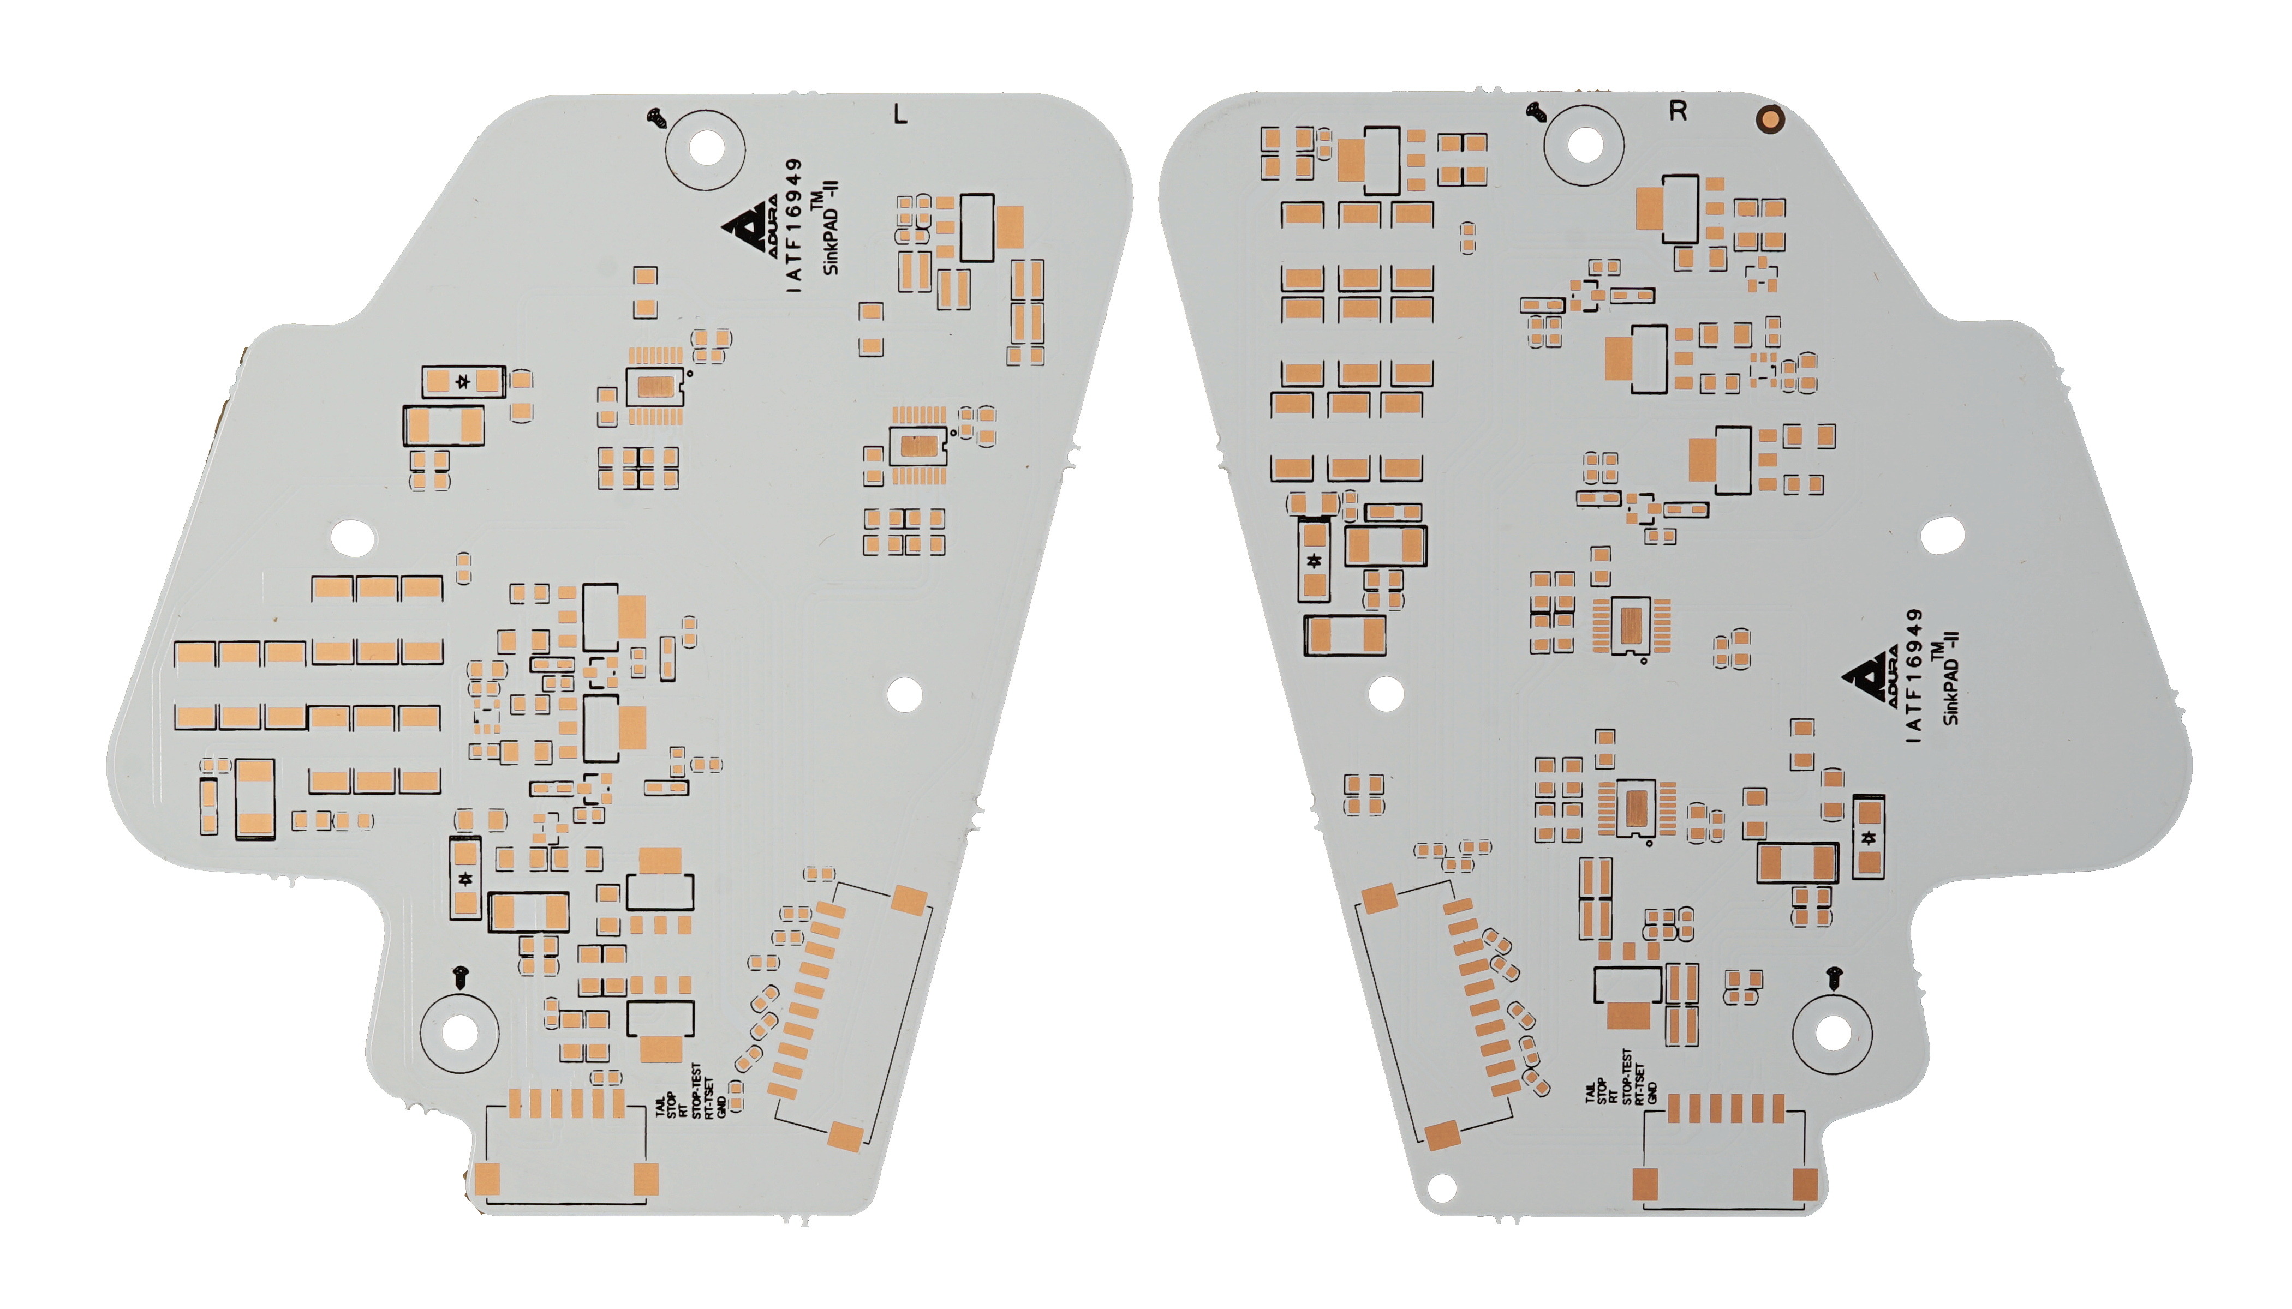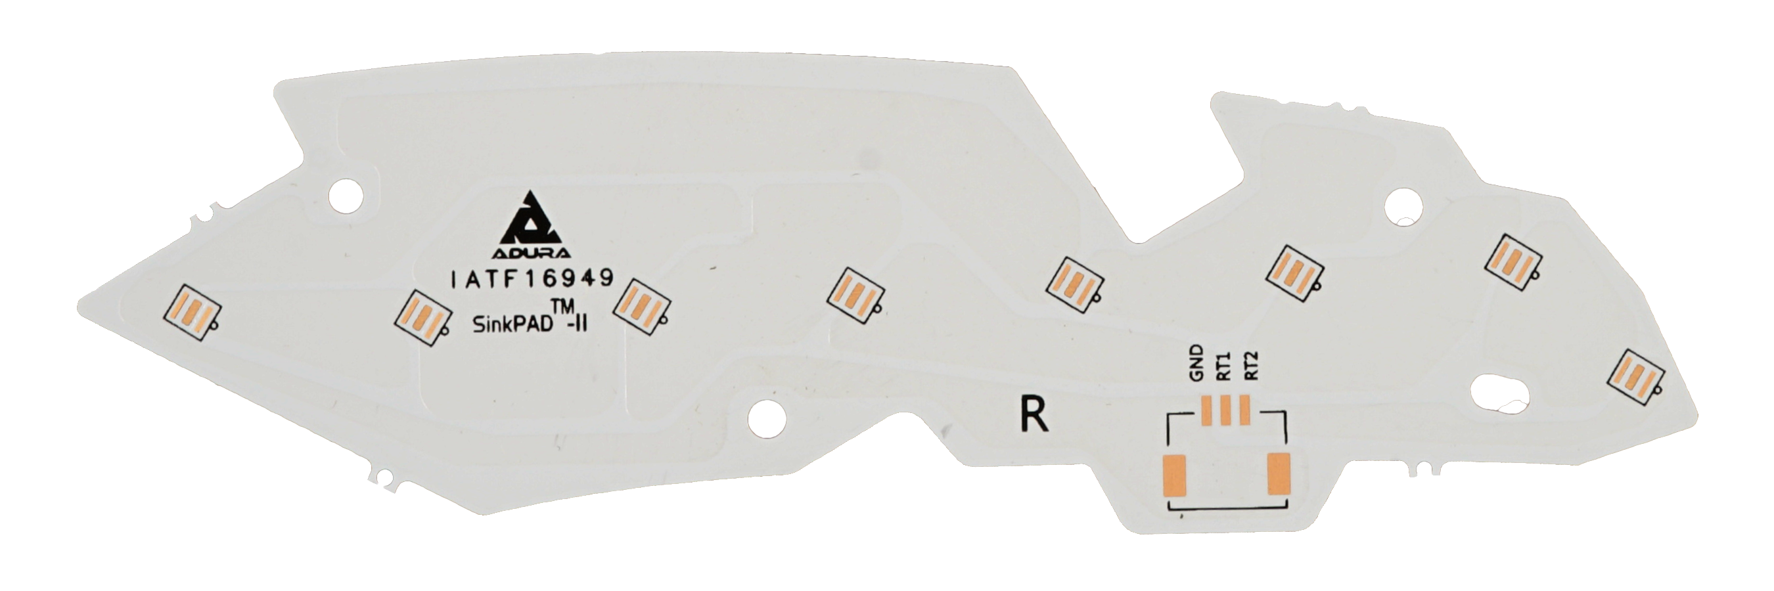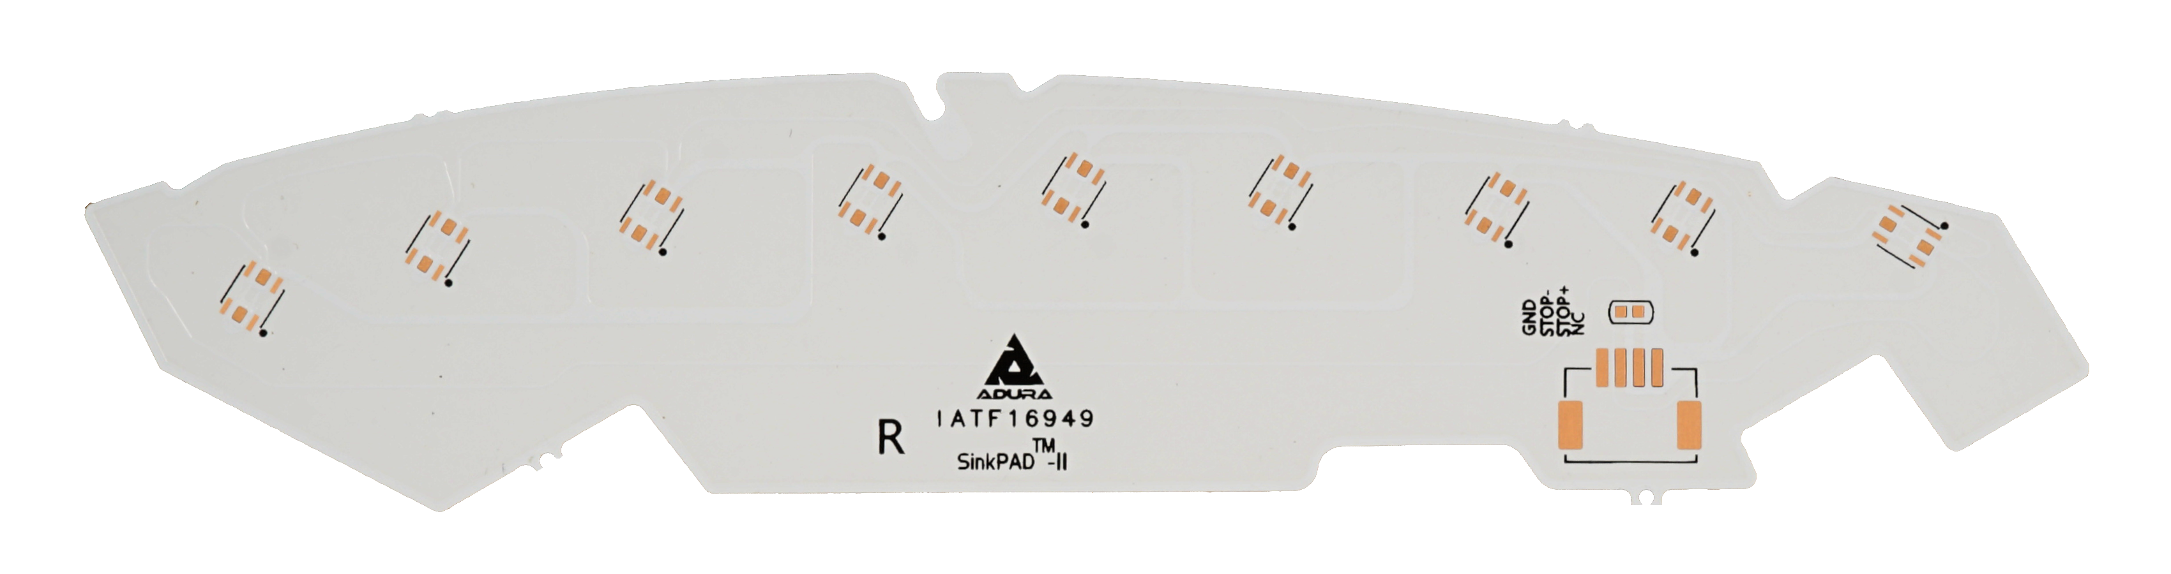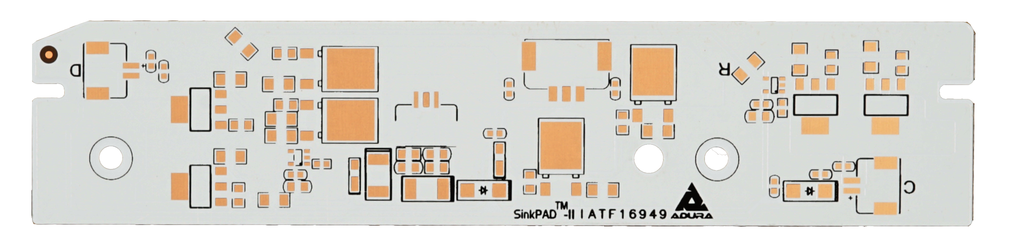

**PCBs**, engineered specifically for high-performance **automotive headlight applications**. These advanced thermal PCBs are custom-designed for reflector, projector, DRL, and high/low beam modules used in **off-road, commercial, and OEM vehicles**.

* Optimized for **superior thermal conductivity**, enabling higher LED drive currents and extended lifespan.
* Custom geometries tailored to **complex headlamp assemblies**, supporting advanced optical systems and tight tolerance requirements.
* Manufactured to meet rigorous **automotive quality standards**, including **AOI, SPI, and through-hole capability**, ensuring reliability in harsh environments.